# Predicting New Hotel Location in Downtown Douala, Cameroon, West Africa

## Introduction

**Discussion of the business problem and the audience who would be interested in this project**

Douala is the largest city in Cameroon (Central Africa) and its economic capital. It is also the capital of Cameroon's Littoral Region. Home to Central Africa's largest port and its major international airport, Douala International Airport (DLA), it is the commercial and economic capital of Cameroon and the entire CEMAC region comprising Gabon, Congo, Chad, Equatorial Guinea, Central African Republic and Cameroon. Consequently, it handles most of the country's major exports, such as oil, cocoa and coffee, timber, metals and fruits. As from 2018, the city and its surrounding area had an estimated population of 2,768,400. The city sits on the estuary of Wouri River and its climate is tropical.

**Business Problem**

I would like to open a hotel/restaurant near beach side. As it is a famous tourist spot, there is already lots of attention towards it. I know there will be many competitors in terms of hotel and restaurant. But keeping them in mind, i need to locate my hotel in place where more people are attracted and comfortable for a stay and a good meal. I want to bring foreign and local people attention towards my new hotel. I would like to flavor my restaurant recipe with Italian, American, typical cameroonian delicacies to grab their taste.

The challenge is to find a suitable location for opening a new hotel / restaurant attracted to all local and foreign people in the centre of all famous venues.

### Expected / Interested Audience

75% local and 25% foreign people visit Douala once in a year. Some people stay for couple of days or more. Also they find some place for hangout or a good meal. Their main focus might be belonging to stay somewhere near to reach venues. Apart from these set of people, students and working professionals are common audience here. So we may need to fascinate them all.

## 2. Data acquisition and cleaning

### 2.1 Data sources

We will be completely working on Foursquare data to explore and try to locate our new hotel where more venues like church, sports centers, beach, museums, shopping centers, memorials that are present nearby.

### 2.2 Data cleaning

## With Foursquare credentials and our core location we were able to Search for hotel & restaurant within 2 KM; the relevant part of JSON file was transformed into a pandas dataframe[¶](https://battleoftheneighborhoods-yanndix.notebooks.azure.com/j/lab" \l "Get-relevant-part-of-JSON-and-transform-it-into-a-pandas-dataframe" \t "_self)

## 

# 3. Methodology section

#### In this section we will perform some data analysis and EDA to find insight from data. We will try to understand the current statistics of all given data. Probably, clustering or centroid of all venues will help us to locate new hotel.

#### There are 29 hotels/restaurants within 1km radius captured by Foursquare data engine. Hotel de ville de Douala is the closest to all other hotels. Hotel Beau sejour remains the farthest. Average distance between all hotels to our core location is 853 meters

## 3.a Explore for other venues around Douala[¶](https://battleoftheneighborhoods-yanndix.notebooks.azure.com/j/lab#3.c-Explore-for-other-venues-around-Douala)

##### A tourist person always wants to visit nearby iconic places. So he wants to reside somewhere nearby to all major venues. We will be exploring more venues around the core location. We will be digging more on main areas or place around 1 km.

## 3.b Extract Venues using Search Queries[¶](https://battleoftheneighborhoods-yanndix.notebooks.azure.com/j/lab#3.d-Extract-Venues-using-Search-Queries)

#### When I searched in google map, I could see there were some venues missing. Temples, Church, Parks and Museums are also more recognized by visitors and local audience. So let’s bring their data inside. We collate venues provided by foursquare and the ones extracted through hitting search query API. We could see that there are some hotels/restaurants in the venues list. So we remove them from the list. We have them in separate dataframe

#### Hotels Map

All venues seem to be dispersed except seashore areas. We have listed out number of hotels and venues around Douala, Bonanjo. There are 29 Hotels/Restaurant and 20 Venues.

#### 

#### 

There are 22 venues within 1km radius captured by Foursquare data engine.

We could see L'Olympia,Spar Douala,Port de Douala are more closer to our location. Akwa Palace Gym is far than rest of places. Musee Maritime is also an important venue which is 700 meters from our location

## 3.j Extracting Rated and Tips Venues

**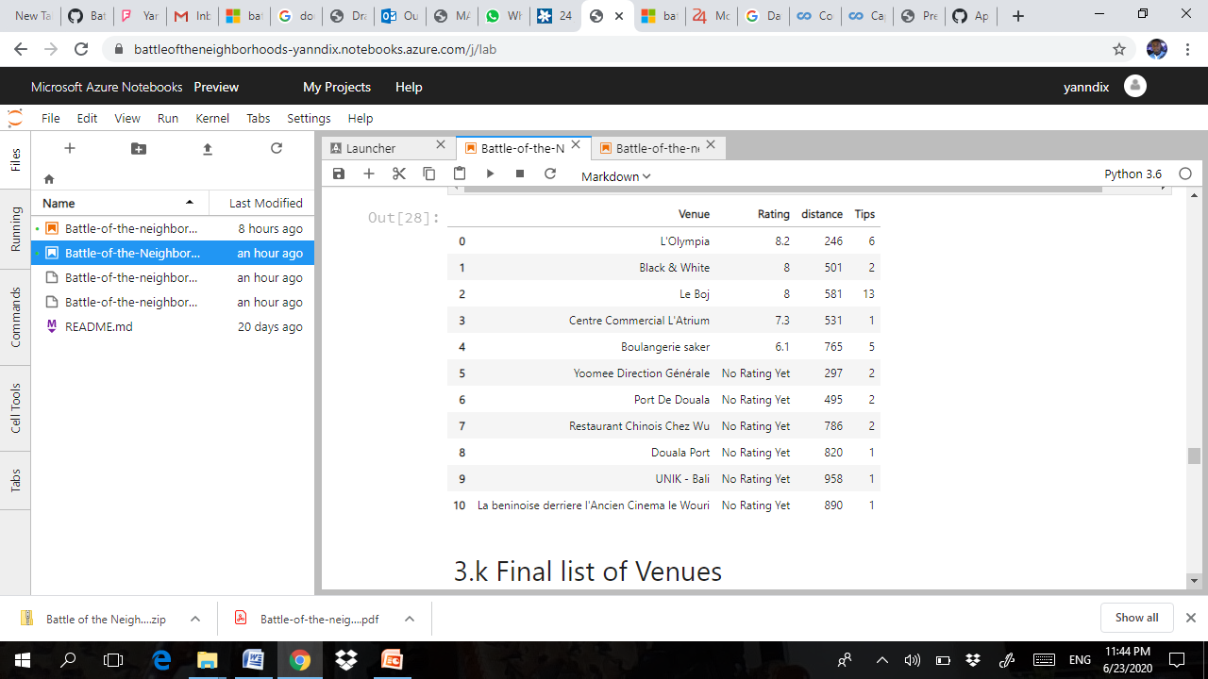**

## 3.k Final list of Venues

**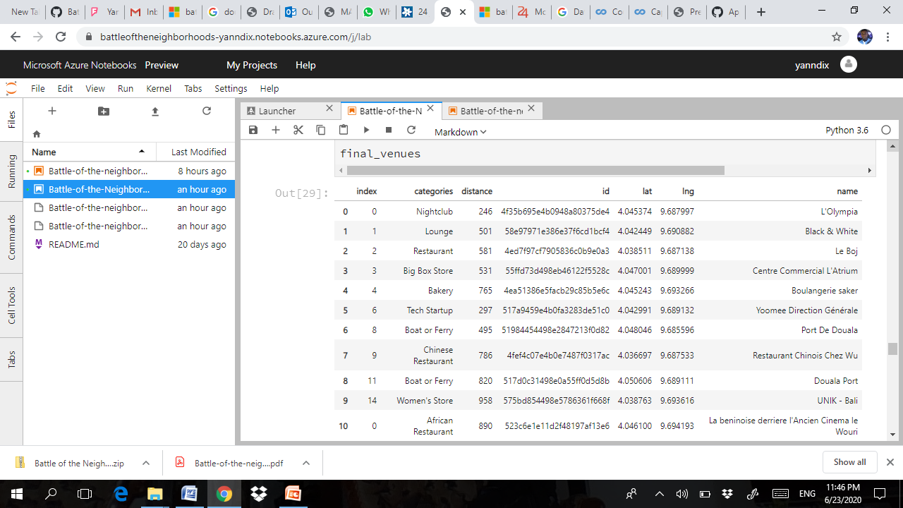**

## 3.l Clustering based on venues

Now lets do some prediction to locate our new hotel in centre of final list of venues

**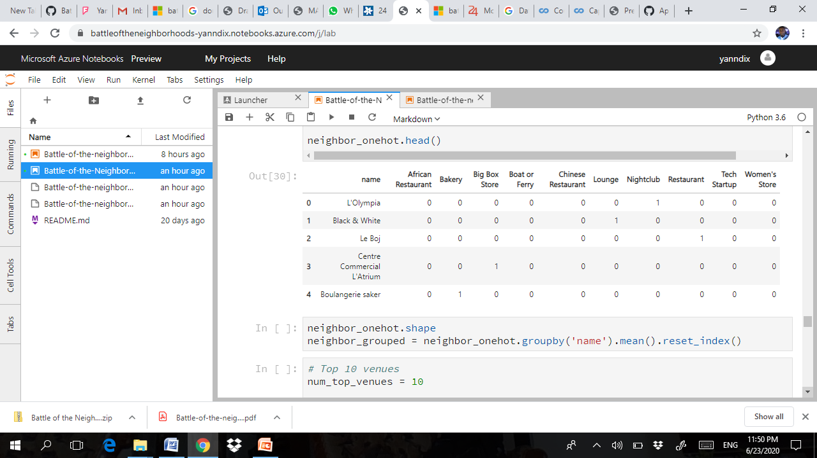**

## 3.m Center of all clusters & Midpoint of all venues[¶](https://battleoftheneighborhoods-yanndix.notebooks.azure.com/j/lab#3.m-Center-of-all-clusters-&amp;-Midpoint-of-all-venues)

### We will be collating the location of centroid of all clusters and midpoint of all venues to get more accurate location.

**Clustering And Midpoint Of Venues**

The idea is to produce the center location of all famous top rated/ tips venues. We take average of all centroids based on clusters found. Then we take the midpoints of all shortlisted rated venues. Finally, we get the mean of both and decide our final location We’ve looked at 3 clusters and they were sorted as shown on the next slide.

**Cluster Map**

The location gives the central point to visit all other venues. Hence this can be locked down to attract all tourists .

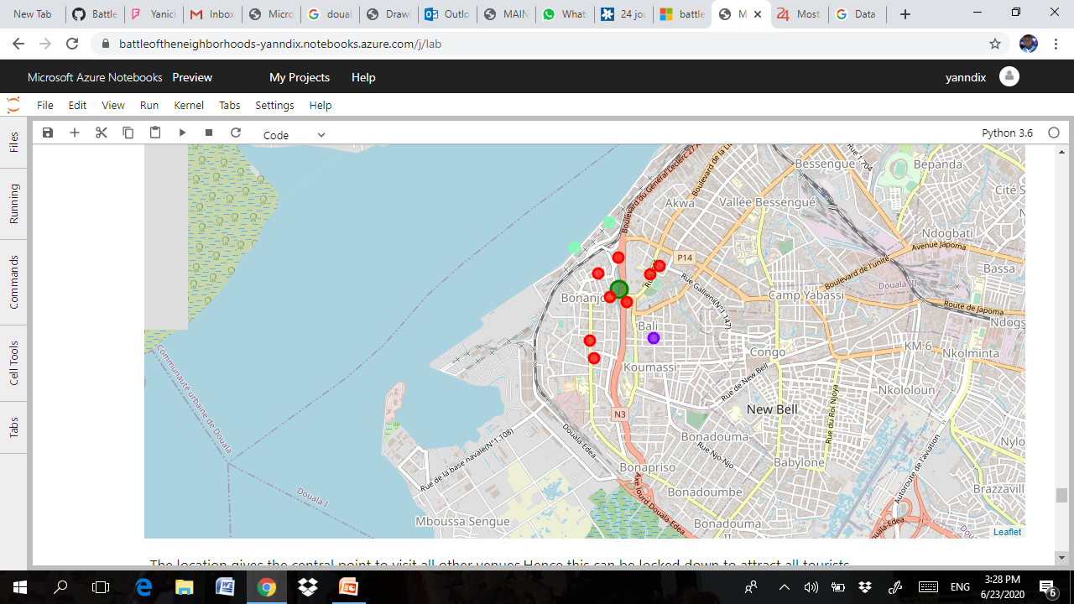Final location is pointed at 4.04391295,9.6901047

My predicted location and core location are very close to each other which is expected, as this has central attraction;

Most common categories of venues are Night clubs, Church, Mall. In downtown Douala, average distance between all hotels is 853 meters.

## 4.b Top Rated Venues

L'Olympia

Black & White

Le Boj

Centre Commercial L'Atrium

All these venues are rated well than other and also they have more tips and located within 320 metres to core location of Douala Bonanjo. So tourists may like to visit these places.

## 4.c Spot my hotel against others

Green - My hotel location

Red - Douala core location.

Black - Venues.

Blue - Other hotels.

My predicted location and core location are very close to each other which is expected. As this has central attraction, the predicted one almost matched with the core.

## 5. Discussion

From above reports, we could get an idea why the predicted one is pointed/clustered on the given spot.

KMeans have figured out the most common place for all the venues. This output was very adjacent to the core location. This proves the accurate spotting of our predicted algorithm.

Despite of the findings, there were some missing data. Tips and ratings were missing for most of the venues. Also when I compared foursquare data with google map , i could see there were many hotels and venues found missing in foursquare.

## 6. Conclusion [¶](https://battleoftheneighborhoods-yanndix.notebooks.azure.com/j/lab#6.-Conclusion-section)

In this study, I analyzed the possibilities of opening a hotel/restaurant near the sea. As it is a famous tourist spot, there is already lots of attention towards it. I knew there will be many competitors in terms of hotel and restaurant. But keeping them in mind, i needed to locate my hotel in place where more people are attracted and comfortable for a stay and a good meal. I wanted to bring foreign and local people attention towards my new hotel. The challenge was to find a suitable location for opening a new hotel / restaurant attracted to all local and foreigners in the center of all famous venues.